PROBLEM STATEMENT -1:
Create a dashboard displaying student details, semester results, attendance percentages, subject information, examination schedules, and announcements. Use tables, progress bars, cards, and a sidebar layout.

PROGRAM CODE:
```html
<!DOCTYPE html>
<html>
<head>
<title>Student Academic Dashboard</title>
<style>
* {
margin: 0;
padding: 0;
box-sizing: border-box;
font-family: Arial;
}
body {
background-color: aliceblue;
color: navy;
}
.dashboard {
display: flex;
min-height: 100vh;
}
.sidebar {
width: 220px;
padding: 20px;
background-color: navy;
}
.sidebar h2 {
color: white;
text-align: center;
margin-bottom: 20px;
}
.sidebar a {
display: block;
color: white;
text-decoration: none;
padding: 12px;
margin: 5px 0;
}
.sidebar a:hover {
background-color: royalblue;
}
.main {
flex: 1;
padding: 20px;
}
.header {
background-color: white;
padding: 20px;
margin-bottom: 20px;
border-radius: 10px;
}
.header h1 {
margin-bottom: 8px;
}
.header p {
color: dimgray;
}
.student {
background-color: white;
padding: 20px;
margin-bottom: 20px;
border-radius: 10px;
}
.details {
display: grid;
grid-template-columns: repeat(4, 1fr);
gap: 10px;
margin-top: 15px;
}
.box {
background-color: lavender;
padding: 15px;
border-radius: 6px;
}
.box b {
display: block;
margin-bottom: 5px;
}
.cards {
display: grid;
grid-template-columns: repeat(3, 1fr);
gap: 15px;
margin-bottom: 20px;
}
.card {
background-color: white;
padding: 20px;
border-radius: 10px;
}
.card h3 {
margin-bottom: 10px;
}
.card p {
font-size: 25px;
font-weight: bold;
}
.gpa {
color: green;
}
.att {
color: royalblue;
}
.sub {
color: orange;
}
.section {
background-color: white;
padding: 20px;
margin-bottom: 20px;
border-radius: 10px;
}
.section h2 {
margin-bottom: 15px;
}
.attendance p {
margin-bottom: 5px;
}
.bar {
height: 15px;
background-color: lightgray;
border-radius: 10px;
margin-bottom: 15px;
}
.fill {
height: 15px;
border-radius: 10px;
}
.python {
width: 85%;
background-color: royalblue;
}
.math {
width: 90%;
background-color: green;
}
.web {
width: 78%;
background-color: orange;
}
.english {
width: 92%;
background-color: mediumseagreen;
}
table {
width: 100%;
border-collapse: collapse;
}
th {
background-color: navy;
color: white;
padding: 10px;
}
td {
text-align: center;
padding: 10px;
border-bottom: 1px solid lightgray;
}
.announcements {
display: grid;
grid-template-columns: repeat(3, 1fr);
gap: 10px;
}
.notice {
background-color: lightyellow;
padding: 15px;
border-left: 5px solid orange;
}
.notice h3 {
color: darkorange;
margin-bottom: 5px;
}
.footer {
text-align: center;
color: dimgray;
padding: 15px;
}
</style>
</head>
<body>
<div class="dashboard">
<div class="sidebar">
<h2>Student Portal</h2>
<a href="#">Dashboard</a>
<a href="#">Student Profile</a>
<a href="#">Results</a>
<a href="#">Attendance</a>
<a href="#">Subjects</a>
<a href="#">Examinations</a>
<a href="#">Announcements</a>
</div>
<div class="main">
<div class="header">
<h1>Student Academic Dashboard</h1>
<p>Welcome back, vignesh!</p>
</div>
<div class="student">
<h2>Student Details</h2>
<div class="details">
<div class="box">
<b>Name</b>
ram
</div>
<div class="box">
<b>Roll Number</b>
24NRI001
</div>
<div class="box">
<b>Branch</b>
CSE
</div>
<div class="box">
<b>Semester</b>
I Semester
</div>
</div>
</div>
<div class="cards">
<div class="card">
<h3>Semester GPA</h3>
<p class="gpa">8.7</p>
</div>
<div class="card">
<h3>Overall Attendance</h3>
<p class="att">86%</p>
</div>
<div class="card">
<h3>Total Subjects</h3>
<p class="sub">6</p>
</div>
</div>
<div class="section">
<h2>Subject Attendance</h2>
<div class="attendance">
<p>Python Fundamentals - 85%</p>
<div class="bar">
<div class="fill python"></div>
</div>
<p>Mathematics - 90%</p>
<div class="bar">
<div class="fill math"></div>
</div>
<p>Web Development - 78%</p>
<div class="bar">
<div class="fill web"></div>
</div>
<p>English - 92%</p>
<div class="bar">
<div class="fill english"></div>
</div>
</div>
</div>
<div class="section">
<h2>Semester Results</h2>
<table>
<tr>
<th>Subject</th>
<th>Marks</th>
<th>Grade</th>
<th>Result</th>
</tr>
<tr>
<td>Python Fundamentals</td>
<td>88</td>
<td>A</td>
<td>Pass</td>
</tr>
<tr>
<td>Mathematics</td>
<td>91</td>
<td>A+</td>
<td>Pass</td>
</tr>
<tr>
<td>Web Development</td>
<td>84</td>
<td>A</td>
<td>Pass</td>
</tr>
<tr>
<td>English</td>
<td>86</td>
<td>A</td>
<td>Pass</td>
</tr>
</table>
</div>
<div class="section">
<h2>Examination Schedule</h2>

<table>
<tr>
<th>Date</th>
<th>Subject</th>
<th>Time</th>
<th>Room</th>
</tr>

<tr>
<td>05 November</td>
<td>Python Fundamentals</td>
<td>10:00 AM</td>
<td>Room 101</td>
</tr>
<tr>
<td>08 November</td>
<td>Mathematics</td>
<td>10:00 AM</td>
<td>Room 102</td>
</tr>
<tr>
<td>11 November</td>
<td>Web Development</td>
<td>10:00 AM</td>
<td>Room 103</td>
</tr>
<tr>
<td>14 November</td>
<td>English</td>
<td>10:00 AM</td>
<td>Room 104</td>
</tr>
</table>
</div>
<div class="section">
<h2>Announcements</h2>
<div class="announcements">
<div class="notice">
<h3>Exam Notice</h3>
<p>Semester examinations will begin from 05 November.</p>
</div>
<div class="notice">
<h3>Assignment</h3>
<p>Submit the Python assignment before the due date.</p>
</div>
<div class="notice">
<h3>Attendance</h3
<p>Students must maintain the required attendance percentage.</p>
</div>
<div class="footer">
<p>Student Academic Dashboard | College Student Portal</p>
</div>
</div>
</div>
</body>
</html>

OUTPUT:
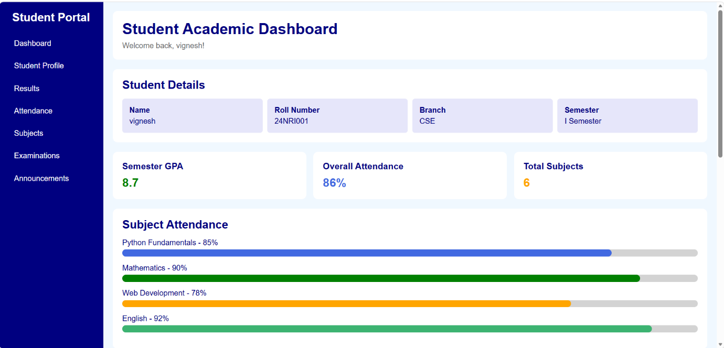
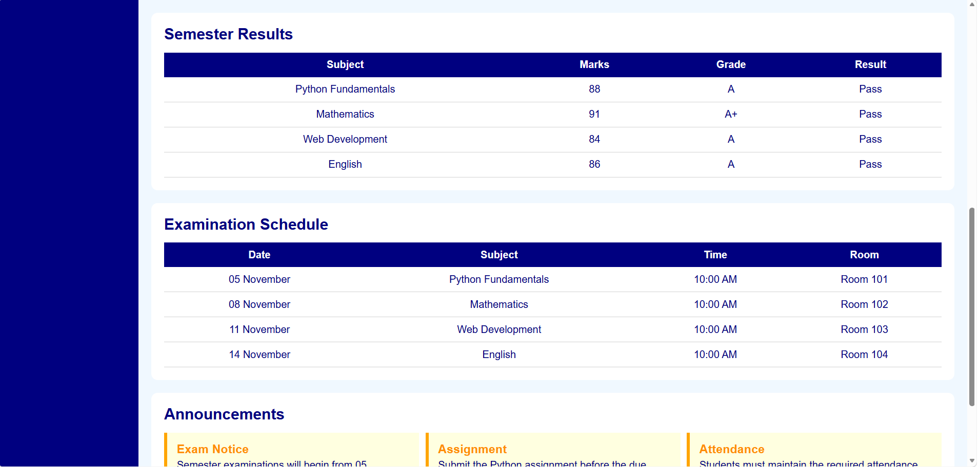

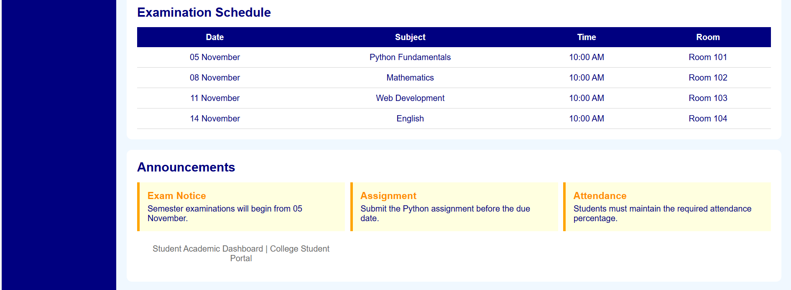

PROBLEM STATEMENT-2:
Build a property website featuring houses, apartments, rental properties, prices, locations, amenities, and property details. Use structured cards, comparison tables, and a search-filter interface.

PROGRAM CODE:
<!DOCTYPE html>
<html>
<head>
<title>Real Estate Property Listing</title>
<style>
* {
margin: 0;
padding: 0;
box-sizing: border-box;
font-family: Arial;
}
body {
background-color: whitesmoke;
color: darkslategray;
}
.header {
background-color: darkblue;
color: white;
padding: 20px;
text-align: center;
}
.header h1 {
margin-bottom: 8px;
}
.search {
background-color: white;
padding: 20px;
margin: 20px;
border-radius: 10px;
}
.search h2 {
margin-bottom: 15px;
color: darkblue;
}
.search-box {
display: grid;
grid-template-columns: repeat(4, 1fr);
gap: 10px;
}
.search-box input,
.search-box select,
.search-box button {
padding: 12px;
border: 1px solid lightgray;
border-radius: 5px;
}
.search-box button {
background-color: darkblue;
color: white;
border: none;
}
.properties {
padding: 0 20px;
}
.properties h2 {
margin-bottom: 15px;
color: darkblue;
}
.property-container {
display: grid;
grid-template-columns: repeat(3, 1fr);
gap: 20px;
}
.property {
background-color: white;
border-radius: 10px;
overflow: hidden;
}
.property-image {
height: 160px;
background-color: lightblue;
display: flex;
align-items: center;
justify-content: center;
color: darkblue;
font-size: 20px;
font-weight: bold;
}
.property-details {
padding: 15px;
}
.property-details h3 {
color: darkblue;
margin-bottom: 8px;
}
.price {
color: green;
font-size: 20px;
font-weight: bold;
margin-bottom: 8px;
}
.location {
color: dimgray;
margin-bottom: 10px;
}
.amenities {
margin-bottom: 10px;
}
.amenities span {
background-color: lavender;
padding: 5px;
margin-right: 5px;
font-size: 13px;
}
.property-details button {
background-color: royalblue;
color: white;
border: none;
padding: 10px 15px;
border-radius: 5px;
}
.comparison {
background-color: white;
padding: 20px;
margin: 20px;
border-radius: 10px;
}
.comparison h2 {
color: darkblue;
margin-bottom: 15px;
}
table {
width: 100%;
border-collapse: collapse;
}
th {
background-color: darkblue;
color: white;
padding: 12px;
}
td {
padding: 12px;
text-align: center;
border-bottom: 1px solid lightgray;
}
.footer {
background-color: darkblue;
color: white;
text-align: center;
padding: 15px;
margin-top: 20px;
}
</style>
</head>
<body>
<div class="header">
<h1>DreamHome Properties</h1>
<p>Find your perfect home</p>
</div>
<div class="search">
<h2>Search Properties</h2>
<div class="search-box">
<input type="text" placeholder="Enter location">
<select>
<option>Property Type</option>
<option>House</option>
<option>Apartment</option>
<option>Villa</option>
<option>Rental</option>
</select>
<select>
<option>Price Range</option>
<option>Below ₹20 Lakhs</option>
<option>₹20 - ₹50 Lakhs</option>
<option>₹50 Lakhs - ₹1 Crore</option>
<option>Above ₹1 Crore</option>
</select>
<button>Search</button>
</div>
</div>
<div class="properties">
<h2>Available Properties</h2>
<div class="property-container">
<div class="property">
<div class="property-image">
Modern House
</div>
<div class="property-details">
<h3>Beautiful Family House</h3>
<p class="price">₹65 Lakhs</p>
<p class="location">Location: Visakhapatnam</p>
<div class="amenities">
<span>3 BHK</span>
<span>2 Bath</span>
<span>Parking</span>
</div>
<p>Spacious house with a garden and modern facilities.</p>
<br>
<button>View Details</button>
</div>
</div>
<div class="property">
<div class="property-image">
Apartment
</div>
<div class="property-details">
<h3>City View Apartment</h3>
<p class="price">₹48 Lakhs</p>
<p class="location">Location: Hyderabad</p>
<div class="amenities">
<span>2 BHK</span>
<span>2 Bath</span>
<span>Lift</span>
</div>
<p>Modern apartment located near shopping and transport facilities.</p>
<br>
<button>View Details</button>
</div>
</div>
<div class="property">
<div class="property-image">
Rental Home
</div>
<div class="property-details">
<h3>Comfortable Rental Home</h3>
<p class="price">₹18,000 / Month</p>
<p class="location">Location: Vijayawada</p>
<div class="amenities">
<span>2 BHK</span>
<span>Parking</span>
<span>Balcony</span>
</div>
<p>Affordable rental home suitable for families and students.</p>
<br>
<button>View Details</button>
</div>
</div>
</div>
</div>
<div class="comparison">
<h2>Property Comparison</h2>
<table>
<tr>
<th>Property</th>
<th>Location</th>
<th>Type</th>
<th>Bedrooms</th>
<th>Price</th>
</tr>
<tr>
<td>Beautiful Family House</td>
<td>Visakhapatnam</td>
<td>House</td>
<td>3 BHK</td>
<td>₹65 Lakhs</td>
</tr>
<tr>
<td>City View Apartment</td>
<td>Hyderabad</td>
<td>Apartment</td>
<td>2 BHK</td>
<td>₹48 Lakhs</td>
</tr>
<tr>
<td>Comfortable Rental Home</td>
<td>Vijayawada</td>
<td>Rental</td>
<td>2 BHK</td>
<td>₹18,000 / Month</td>
</tr>
</table>
</div>
<div class="footer">
<p>DreamHome Properties | Find Your Perfect Home</p>
</div>
</body>
</html>

OUTPUT:
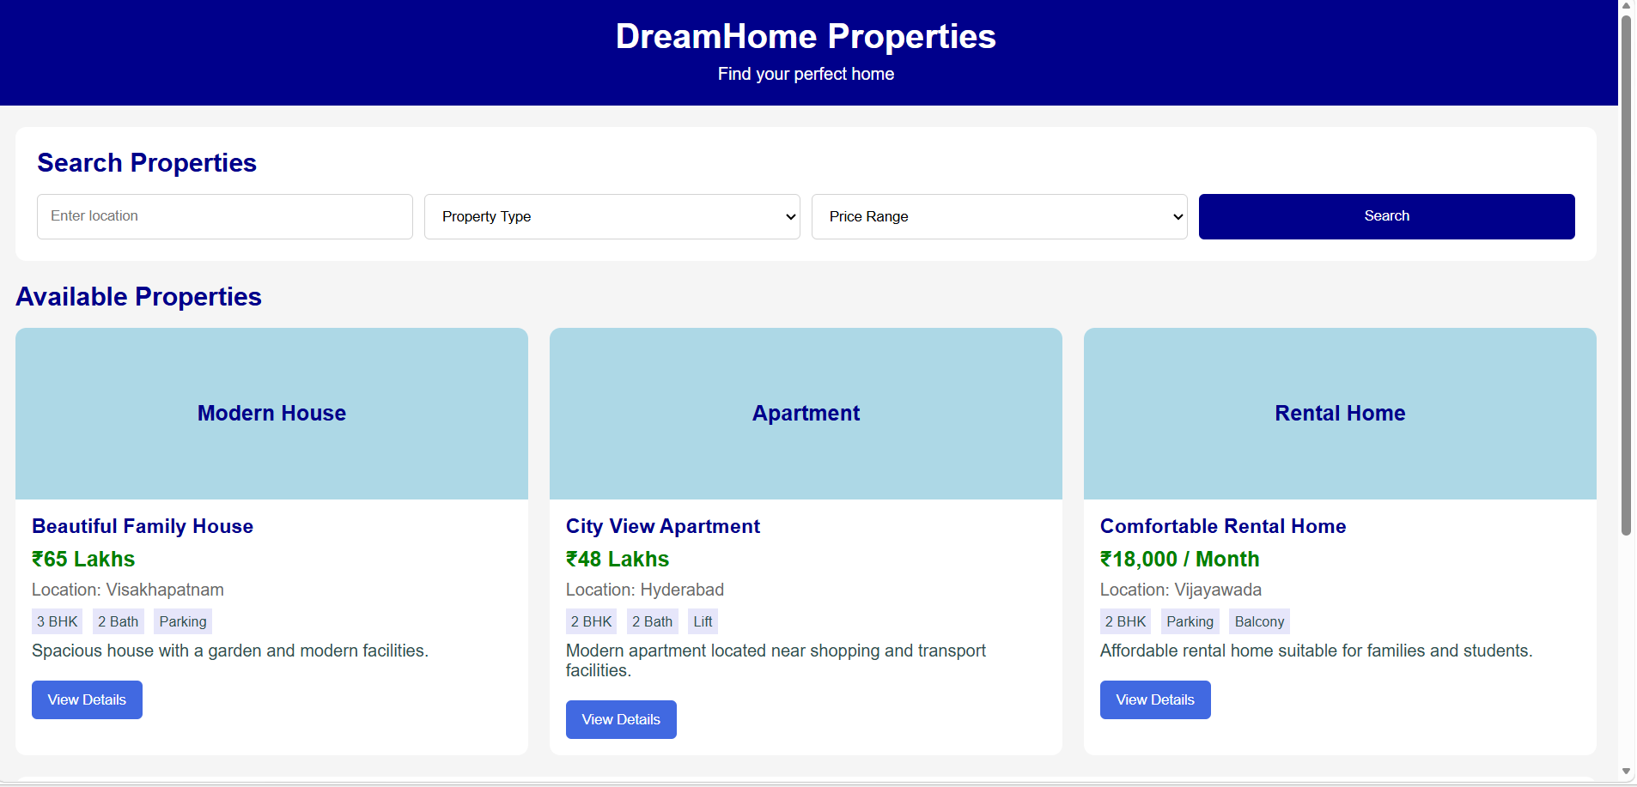
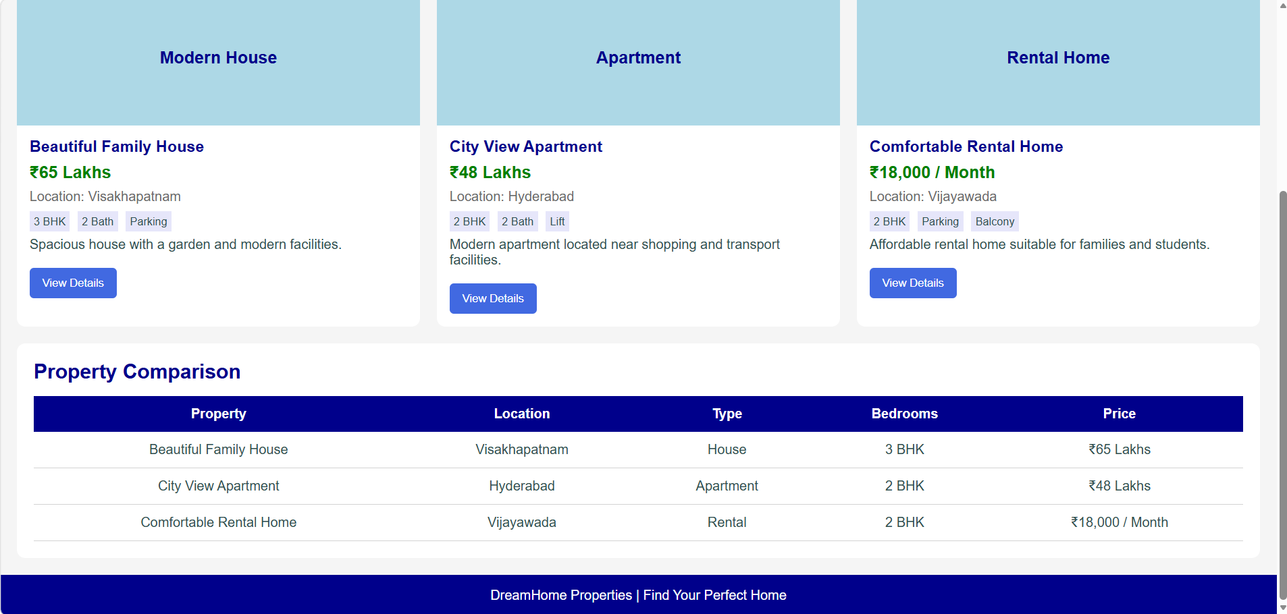

PROBLEM STATEMENT-3:
Create a restaurant website with menu sections, chef profiles, restaurant ambience, customer testimonials, opening hours, location details, and table reservation forms. Use a responsive menu and elegant typography.

PROGRAM CODE:
<!DOCTYPE html>
<html>
<head>
<title>Restaurant and Cafe Website</title>
<style>
* {
margin: 0;
padding: 0;
box-sizing: border-box;
font-family: Georgia;
}
body {
background-color: floralwhite;
color: darkslategray;
}
.header {
background-color: maroon;
color: white;
padding: 20px;
text-align: center;
}
.header h1 {
margin-bottom: 8px;
}
.nav {
background-color: darkred;
padding: 12px;
text-align: center;
}
.nav a {
color: white;
text-decoration: none;
margin: 0 15px;
}
.welcome {
background-color: lightyellow;
padding: 30px;
margin: 20px;
text-align: center;
border-radius: 10px;
}
welcome h2 {
color: maroon;
margin-bottom: 10px;
}
.menu {
padding: 0 20px;
}
.menu h2 {
color: maroon;
margin-bottom: 15px;
text-align: center;
}
.menu-container {
display: grid;
grid-template-columns: repeat(3, 1fr);
gap: 20px;
}
.menu-card {
background-color: white;
padding: 20px;
border-radius: 10px;
text-align: center;
}
.menu-card h3 {
color: maroon;
margin-bottom: 8px;
}
.menu-card p {
margin-bottom: 10px;
}
.price {
color: green;
font-weight: bold;
font-size: 18px;
}
.chef {
background-color: mistyrose;
padding: 20px;
margin: 20px;
border-radius: 10px;
}
.chef h2 {
color: maroon;
margin-bottom: 15px;
text-align: center;
}
.chef-container {
display: grid;
grid-template-columns: repeat(3, 1fr);
gap: 20px;
}
.chef-card {
background-color: white;
padding: 15px;
text-align: center;
border-radius: 10px;
}
.chef-image {
height: 120px;
background-color: lightgray;
display: flex;
align-items: center;
justify-content: center;
margin-bottom: 10px;
color: maroon;
font-weight: bold;
}
.ambience {
background-color: white;
padding: 20px;
margin: 20px;
border-radius: 10px;
text-align: center;
}
.ambience h2 {
color: maroon;
margin-bottom: 10px;
}
.testimonials {
background-color: lavenderblush;
padding: 20px;
margin: 20px;
border-radius: 10px;
}
.testimonials h2 {
color: maroon;
text-align: center;
margin-bottom: 15px;
}
.testimonial-container {
display: grid;
grid-template-columns: repeat(3, 1fr);
gap: 20px;
}
.testimonial {
background-color: white;
padding: 15px;
border-radius: 10px;
text-align: center;
}
.reservation {
background-color: white;
padding: 20px;
margin: 20px;
border-radius: 10px;
}
.reservation h2 {
color: maroon;
margin-bottom: 15px;
text-align: center;
}
.reservation-form {
display: grid;
grid-template-columns: repeat(2, 1fr);
gap: 10px;
}
.reservation-form input,
.reservation-form select,
.reservation-form button {
padding: 12px;
border: 1px solid lightgray;
border-radius: 5px;
}
.reservation-form button {
background-color: maroon;
color: white;
border: none;
}
.info {
background-color: beige;
padding: 20px;
margin: 20px;
border-radius: 10px;
text-align: center;
}
.info h2 {
color: maroon;
margin-bottom: 10px;
}
.footer {
background-color: maroon;
color: white;
text-align: center;
padding: 15px;
margin-top: 20px;
}
</style>
</head>
<body>
<div class="header">
<h1>Spice Garden Restaurant</h1>
<p>Delicious Food | Great Taste | Happy Moments</p>
</div>
<div class="nav">
<a href="#">Home</a>
<a href="#">Menu</a>
<a href="#">Chefs</a>
<a href="#">Reservation</a>
<a href="#">Contact</a>
</div>
<div class="welcome">
<h2>Welcome to Spice Garden</h2>
<p>Enjoy delicious food prepared with fresh ingredients in a comfortable atmosphere.</p>
</div>
<div class="menu">
<h2>Our Menu</h2>
<div class="menu-container">
<div class="menu-card">
<h3>Paneer Tikka</h3>
<p>Grilled paneer with spices and vegetables.</p>
<p class="price">₹220</p>
</div>
<div class="menu-card">
<h3>Chicken Biryani</h3>
<p>Traditional biryani with aromatic rice and spices.</p>
<p class="price">₹280</p>
</div>
<div class="menu-card">
<h3>Veg Pizza</h3>
<p>Fresh vegetables with cheese and special sauce.</p>
<p class="price">₹250</p>
</div>
<div class="menu-card">
<h3>Masala Dosa</h3>
<p>Crispy dosa served with chutney and sambar.</p>
<p class="price">₹120</p>
</div>
<div class="menu-card">
<h3>Chocolate Brownie</h3>
<p>Soft chocolate brownie served with ice cream.</p>
<p class="price">₹150</p>
</div>
<div class="menu-card">
<h3>Fresh Lime Soda</h3>
<p>Refreshing lime drink with a sweet and sour taste.</p>
<p class="price">₹80</p>
</div>
</div>
</div>
<div class="chef">
<h2>Meet Our Chefs</h2>
<div class="chef-container">
<div class="chef-card">
<div class="chef-image">
Chef Photo
</div>
<h3>Chef Arjun</h3>
<p>Head Chef</p>
<p>Specialist in Indian and traditional dishes.</p>
</div>
<div class="chef-card">
<div class="chef-image">
Chef Photo
</div>
<h3>Chef Priya</h3>
<p>Pastry Chef</p>
<p>Specialist in desserts and bakery items.</p>
</div>
<div class="chef-card">
<div class="chef-image">
Chef Photo
</div>
<h3>Chef Rahul</h3>
<p>Continental Chef</p>
<p>Specialist in pizzas, pasta and continental food.</p>
</div>
</div>
</div>
<div class="ambience">
<h2>Restaurant Ambience</h2>
<p>Our restaurant provides a clean, peaceful and comfortable environment for families, friends and special occasions.</p>
<br>
<p>Enjoy soft lighting, comfortable seating and pleasant music while having your favourite food.</p>
</div>
<div class="testimonials">
<h2>Customer Testimonials</h2>
<div class="testimonial-container">
<div class="testimonial">
<p>"The food was very tasty and the service was excellent."</p>
<br>
<h4>- Ananya</h4>
</div>
<div class="testimonial">
<p>"A perfect place for family dinner. The ambience is very nice."</p>
<br>
<h4>- Rahul</h4>
</div>
<div class="testimonial">
<p>"Loved the biryani and desserts. Will visit again."</p>
<br>
<h4>- Sneha</h4>
</div>
</div>
</div>
<div class="reservation">
<h2>Table Reservation</h2>
<div class="reservation-form">
<input type="text" placeholder="Your Name">
<input type="text" placeholder="Phone Number">
<input type="date">
<input type="time">
<select>
<option>Number of Guests</option>
<option>1 Guest</option>
<option>2 Guests</option>
<option>3 Guests</option>
<option>4 Guests</option>
<option>5+ Guests</option>
</select>
<select>
<option>Choose Table</option>
<option>Indoor Table</option>
<option>Outdoor Table</option>
<option>Family Table</option>
</select>
<button>Reserve Table</button>
</div>
</div>
<div class="info">
<h2>Opening Hours & Location</h2>
<p>Monday - Friday: 11:00 AM - 10:00 PM</p>
<p>Saturday - Sunday: 10:00 AM - 11:00 PM</p>
<br>
<p>Location: Beach Road, Visakhapatnam, Andhra Pradesh</p>
<p>Phone: 98765 43210</p>
</div>
<div class="footer">
<p>Spice Garden Restaurant | Taste the Happiness</p>
</div>
</body>
</html>

OUTPUT:
